**SCHEMES OF WORK FOR BASIC 7 THIRD TERM (OMEGA TERM)**

**WEEK 1 REVISION OF SECOND TERM’S**

**WEEK 2 SIMPLE EQUATION**

**WEEK 3 GEOMETRY: PLANE SHAPES**

**WEEK 4 THREE DIMESIONAL SHAPES**

**WEEK 5 IDENTIFICATION AND PROPERTIES OF ANGLES**

**WEEK 6 THEOREMS**

**WEEK 7 REVIEW OF FIRST HALF TERM’S**

**WEEK 8 CONSTRUCTION**

**WEEK 9 STATISTICS**

**WEEK 10 STATISTICS**

**WEEK 11 REVISION**

**WEEK 12 EXAMINATION**

**WEEK 1**

**TOPIC: SIMPLE EQUATION**

This expression 3 x p= 18 is an algebraic sentence. It means three times an unknown numbers is equal to eighteen.

Translate the following equations into words.

5x + 7 = 37 it means if 7 is added to five times a number, the result is 37

11 = 3x – 1. It means 11 is equal to 3 times a certain number minus one.

**TRUE AND FALSE STATEMENT**

EXAMPLES: State whether the following is true or false

1. X + 8 = 15 ( when x is 7)
2. 3x – 4 = 11 ( when x is 6)

Solution

X + 8 = 15

7 + 8 = 15. Therefore the statement is true.

Solution

3x – 4 = 11

3*6 – 4 = 11

18 – 4 = 14 therefore the statement is false.

**LINEAR EQUAUTION WITH MIXED OPERATION AND COLLECTION OF LIKE TERMS**

When the operation are more than one,

1. Eliminate the unwanted terms by either adding or subtraction
2. Then eliminate the co efficient of the unknown by either multiplying or dividing.

Examples

1. **4y – 5 = 7**

Solution

Add 5 to both sides

4y -5 + 5 = 7 + 5

4y = 12

Divide both sides by the coefficient of the unknown

4y/4 = 12/4

Y = 3

1. **5x -10 = 15x -60**

Solution

5x – 10 = 15x – 60

Collect the like terms

5x -15 x = -60 + 10

-10x = -50

Divide both sides by -10 (Coefficient of the unknown)

-10x/-10 = -50/ -10

X = 5.

**Do these**

Solve the following equation

1. 6m + 2 = 20 + 5m
2. 4c – 8 = 10 – 5c
3. 5x +5 = 35+ 2x
4. 56 +7y = 5y + 16

**ASSIGNMENT**: Page 151 Exercise 14.6 (Nos 1, 5,15,21,31 and 38**) and** PAGE 153 EX 14.8 NO 2 (a,b,c and d) NO 3 (a,b,c and d)

**WEEK 2:**

**TOPIC: GEOMETRY (PLANE SHAPES AND THEIR PROPERTIES)**

There are two types of plane shapes

**Regular and Irregular shapes.**

1. **TRIANGLES:** Triangles is a three sides plane shapes with three angles.

### Types and Properties of Triangles

Equilateral Triangles

Triangles with all three sides equal in length and all three angles equal in magnitude, are called equilateral triangles. Since the angles in a triangle sum to 180° and the size of each angle is the same in an equilateral triangle, the angles are all 60°.

[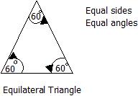](http://wizznotes.com/wp-content/uploads/2011/01/image0111.jpg)

Isosceles Triangles

Isosceles triangles are triangles with two sides equal in length and two angles equal in magnitude.

[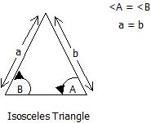](http://wizznotes.com/wp-content/uploads/2011/01/image0121.jpg)

Scalene Triangles

A scalene triangle is one which has no sides equal in length and no angles equal in magnitude.

[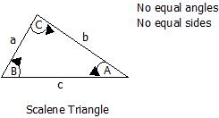](http://wizznotes.com/wp-content/uploads/2011/01/image013.jpg)

Right-Angled Triangles

Right-angled triangles are triangles with one of their angles equal to 90° (i.e. a right angle).

[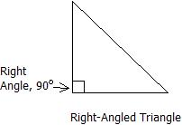](http://wizznotes.com/wp-content/uploads/2011/01/image014.jpg)

# QUADRILATERALS

Quadrilateral just means "four sides" (*quad* means four, *lateral* means side).**A Quadrilateral has four-sides**, it is **2-dimensional** (a flat shape), **closed** (the lines join up), and has **straight** sides.

## Types of Quadrilaterals

There are special types of quadrilateral:

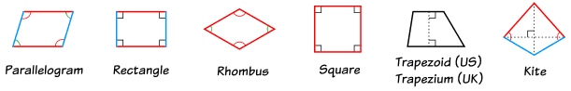

Some types are also included in the definition of other types! For example a **square**, **rhombus** and **rectangle** are also ***parallelograms***.

**TYPES AND PROPERTIES OF QUADRILATERALS**

Quadrilaterals are any four-sided figure, joined by four straight lines, that is, Quadrilaterals are four-sided polygons.

Properties of Quadrilaterals:

-Four sides.

-Four vertices (corners).

-Interior angles sum to 360°.

-Exterior angles sum to 360°.

Things to Know:

-Diagonals are line segments that join two opposite vertices (corners).

[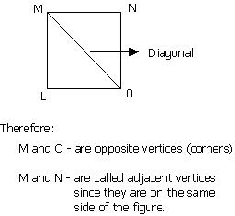](http://wizznotes.com/wp-content/uploads/2011/01/image019.jpg)

-Two sides are adjacent, if they share a common vertex.

[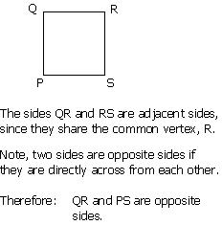](http://wizznotes.com/wp-content/uploads/2011/01/image020.jpg)

-Two angles are adjacent, if they share a common side.

[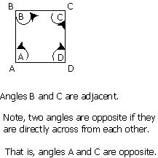](http://wizznotes.com/wp-content/uploads/2011/01/image021.jpg)

**RECTANGLE**

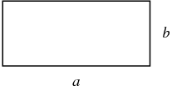

A closed planar [quadrilateral](http://mathworld.wolfram.com/Quadrilateral.html) with opposite sides of equal lengths aand b, and with four [right angles](http://mathworld.wolfram.com/RightAngle.html). A [square](http://mathworld.wolfram.com/Square.html) is a degenerate rectangle with a=b. The [area](http://mathworld.wolfram.com/Area.html) of the rectangle is  A=ab,  and its [polygon diagonals](http://mathworld.wolfram.com/PolygonDiagonal.html)pand qare of length A [rectangle](https://www.mathsisfun.com/geometry/rectangle.html) is a four-sided shape where every angle is a [right angle](https://www.mathsisfun.com/rightangle.html) (90°). Also **opposite sides** are [parallel](https://www.mathsisfun.com/geometry/parallel-lines.html) and of equal length.

|  |  |  |
| --- | --- | --- |
| Rectangle |  |  |
| https://www.mathsisfun.com/images/quadrilateral-right-key.gif | *means "right angle"* |
| https://www.mathsisfun.com/images/quadrilateral-equal-key.gifandhttps://www.mathsisfun.com/images/quadrilateral-equal-key2.gif | *show equal sides* |

RECTANGLE

[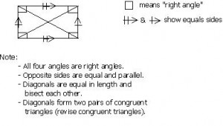](http://wizznotes.com/wp-content/uploads/2011/01/image022.jpg)

**RHOMBUS**

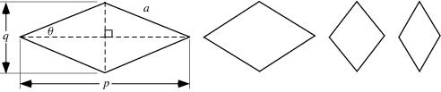

A [quadrilateral](http://mathworld.wolfram.com/Quadrilateral.html) with both pairs of opposite sides [parallel](http://mathworld.wolfram.com/Parallel.html) and all sides the same length, i.e., an [equilateral](http://mathworld.wolfram.com/EquilateralPolygon.html)[parallelogram](http://mathworld.wolfram.com/Parallelogram.html). The word rhomb is sometimes used instead of rhombus, and a rhombus is sometimes also called a diamond. A rhombus with 2theta=45 degreesis sometimes called a [lozenge](http://mathworld.wolfram.com/Lozenge.html).

The [polygon diagonals](http://mathworld.wolfram.com/PolygonDiagonal.html)pand qof a rhombus are [perpendicular](http://mathworld.wolfram.com/Perpendicular.html) and satisfy

|  |  |
| --- | --- |
| p^2+q^2=4a^2. | (1) |

## THE RHOMBUS

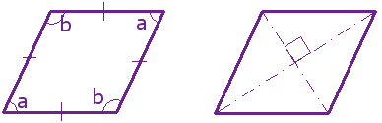

A [rhombus](https://www.mathsisfun.com/geometry/rhombus.html) is a four-sided shape where all sides have equal length. Also opposite sides are parallel *and* opposite angles are equal.

Another interesting thing is that the diagonals (dashed lines in second figure) meet in the middle at a right angle. In other words they "bisect" (cut in half) each other at right angles.

A rhombus is sometimes called a **rhomb** or a **diamond**.

Rhombus

[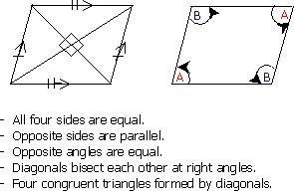](http://wizznotes.com/wp-content/uploads/2011/01/image023.jpg)

***SQUARE***

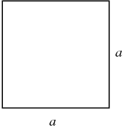

The term "square" can be used to mean either a [square number](http://mathworld.wolfram.com/SquareNumber.html) ("x^2 is the square of x") or a geometric figure consisting of a convex [quadrilateral](http://mathworld.wolfram.com/Quadrilateral.html) with sides of equal length that are positioned at [right angles](http://mathworld.wolfram.com/RightAngle.html) to each other as illustrated above. In other words, a square is a [regular polygon](http://mathworld.wolfram.com/RegularPolygon.html) with four sides.

The [perimeter](http://mathworld.wolfram.com/Perimeter.html) of a square with side length ais

|  |  |
| --- | --- |
| L=4a  and the Area is  A=a^2. | (1) |
|  |  |
|  | (2) |

Square

[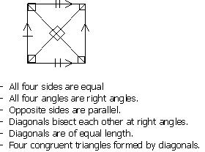](http://wizznotes.com/wp-content/uploads/2011/01/image024.jpg)

## THE PARALLELOGRAM

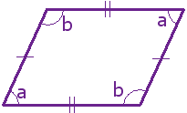

A [parallelogram](https://www.mathsisfun.com/geometry/parallelogram.html) has opposite sides parallel and equal in length. Also opposite angles are equal (angles "a" are the same, and angles "b" are the same).

NOTE: Squares, Rectangles and Rhombuses are all Parallelograms!

Parallelogram

[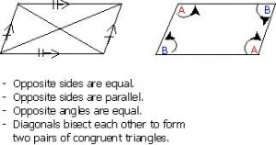](http://wizznotes.com/wp-content/uploads/2011/01/image025.jpg)

Trapezium

[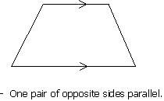](http://wizznotes.com/wp-content/uploads/2011/01/image026.jpg)

Isosceles Trapezium

[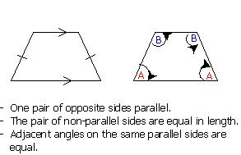](http://wizznotes.com/wp-content/uploads/2011/01/image027.jpg)

Kite

[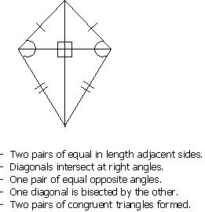](http://wizznotes.com/wp-content/uploads/2011/01/image028.jpg)

**KITE**

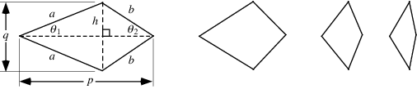

A planar convex [quadrilateral](http://mathworld.wolfram.com/Quadrilateral.html) consisting of two adjacent sides of length aand the other two sides of length b. The [rhombus](http://mathworld.wolfram.com/Rhombus.html) is a special case of the kite, and the [lozenge](http://mathworld.wolfram.com/Lozenge.html) is a special case of the [rhombus](http://mathworld.wolfram.com/Rhombus.html). The [area](http://mathworld.wolfram.com/Area.html) of a kite is given by

 A=1/2pq, 

|  |
| --- |
|  |

## The Kite

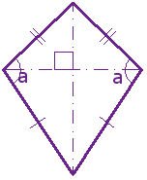It has two pairs of sides. Each pair is made up of adjacent sides (they meet) that are equal in length. The angles are equal where the pairs meet. Diagonals (dashed lines) meet at a right angle, and one of the diagonal bisects (cuts equally in half) the other.

|  |
| --- |
|  |

## IRREGULAR QUADRILATERALS

The only [regular](https://www.mathsisfun.com/geometry/regular-polygons.html) quadrilateral is a square. So all other quadrilaterals are **irregular**.

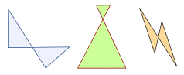

## The "Family Tree" Chart

Quadrilateral definitions are **inclusive**.

### Example: a square is also a rectangle.

So we **include** a square in the definition of a rectangle.

*(We* ***don't*** *say "Having all 90° angles makes it a rectangle except when all sides are equal then it is a square.")*

This may seem odd, as in daily life we think of a square as **not** being a rectangle ... but in mathematics it **is**.

Using the chart below you can answer such questions as:

* Is a Square a type of Rectangle? (Yes)
* Is a Rectangle a type of Kite? (No)

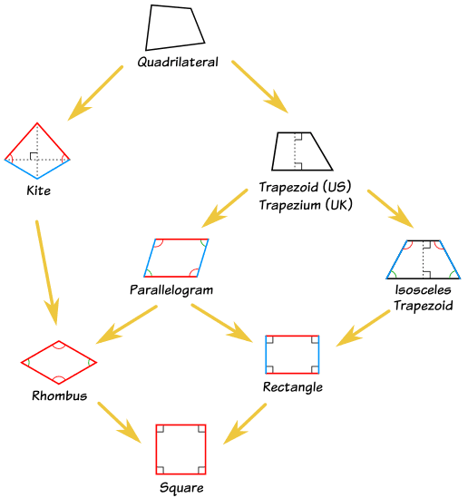

Do these

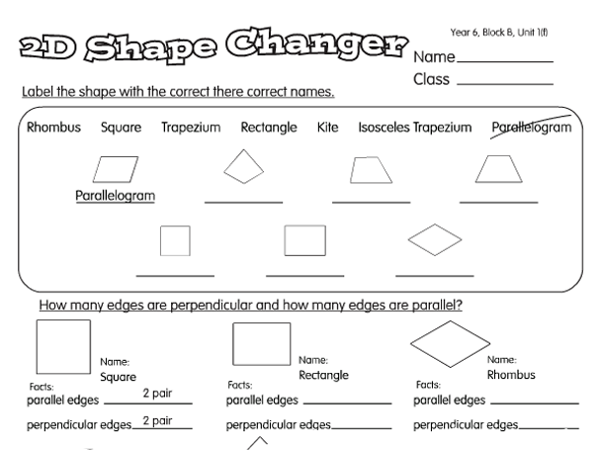

Top of Form

Bottom of Form

Top of Form

Bottom of Form

ASSIGNMENT

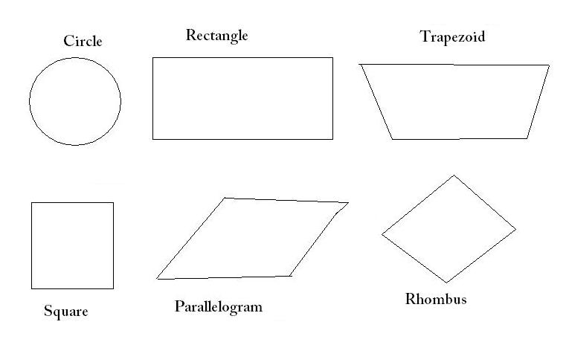

Write at least three properties each of the following shapes

**WEEK 3.**

**TOPIC: AREA AND PERIMETER OF PLANE SHAPES**

**PERIMETER:** The perimeter of a plane shape is the length of its outside boundary. This means the distance round its edges.

**Examples**

1. The length of a rectangular room is 5m and the width is 4m. find the perimeter of the room

Solution

The length of the room = 5m

The width of the room = 4m

Perimeter = 2(l+w)

Perimeter = 2(5+4)

Perimeter = 2(9)= 2x9= **18m**

1. The perimeter of a square is 2580cm. find the length of the square in meter.

Solution:

P= 2580cm = 25.8m

P= 4 x length = 4l

L = 25.8/4

L = 6.45m

Therefore, the length of the square = 6.45m

1. Calculate the perimeter of a triangle with dimensions 4.2m, 3.6m and 5.7m.

Solution:

Perimeter = (4.2 + 3.6 + 5.7) meters

Perimeter **= 13.5m**

1. A parallelogram has sides measuring 200mm by 150mm. what would be the length of the side of a square having the same perimeter?

Solution

Length of parallelogram = 200mm

The width of the parallelogram = 150mm

Perimeter = 2( L + w)

Perimeter = 2(200 + 150) mm

Perimeter = 2 x 350 = 700mm

But

Perimeter of the square = 4 x length = 4L

4L = 700mm

Divide both sides by the coefficient of l

L = 700/4 = 175

Therefore length of the square = **175mm**

1. Calculate the perimeter of a circle of diameter 14cm.

NOTE: The perimeter of a circle is called circumference and the diameter (D) is twice the radius (r). thus D = 2r

Solution:

Method 1: circumference = πd

$$C=πd$$

C = 22/7 x 14

C = **44cm**

Method 2: $∁ =2πr$

R = D/2 = 14/2 = 7cm

C = 2 x 22/7 x 7

C= 44cm

**AREA:** Area of shapes is the measure of amount of surface it covers or occupies.

Examples :

1. Calculate the area of rectangular room with dimension 250cm by 200cm.

Solution: $A=l x b$

A = (250 x 200) square cm

A =50 000 cm square.

1. Find the area of a square of sides 14cm.

Solution: $A=l x l$

A = 14 x 14

A = 196 cm square

1. Evaluate the area of a parallelogram with base 8cm and height 9cm.

Solution:

$A=b x h$

A = 8 X 9

A = 72 cm square

1. Calculate the area of a trapezium with parallel sides 10cm and 18cm and height 12cm.

Solution:

Area = $\frac{1}{2} \left(sum of parallel sides\right)x height$

Area = ½ (10 + 18) x 12

Area = ½ (28) x 12

Area = 14 x 12

Area = 168 cm square.

**Do these**

Exercise 18.2 pg 198 No (2, 3,4 & 5)

Exercise 18.3 pg 200 No (2, 3, 4 & 5)

**Assignment**

Exercise 18.6 pg 209 No (2, 4, 5,9 & 10)

**WEEK 4**

**TOPIC: THREE DIMENSIONAL SHAPES**

Solid figure are often called 3dimensional shapes. A solid figure is simply anything that occupied space and also has a definite shape.

**FACES, EDGES AND VERTICES**

**FACE:** A face is the surface of a solid which is enclosed by edges.

**EDGES:** An edge of a solid is a line where two faces meet. Note that an edge may be straight or curved

**VERTEX:** A vertex of a solid is a point or corner where three or more edges meet.

**TYPES OF SOLID AND THEIR PROPERTIE**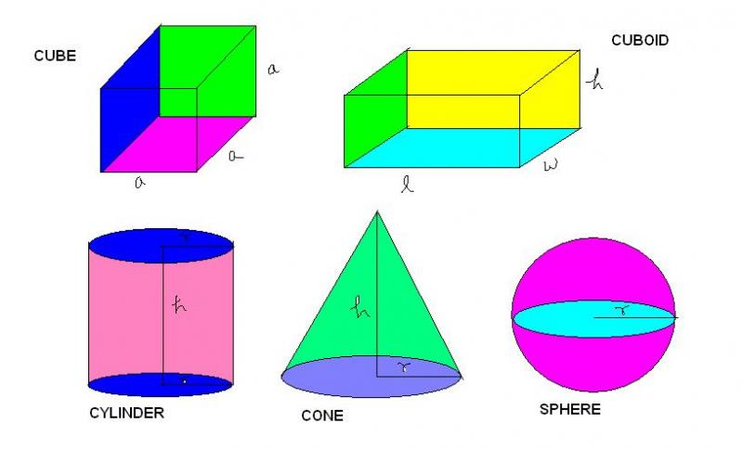

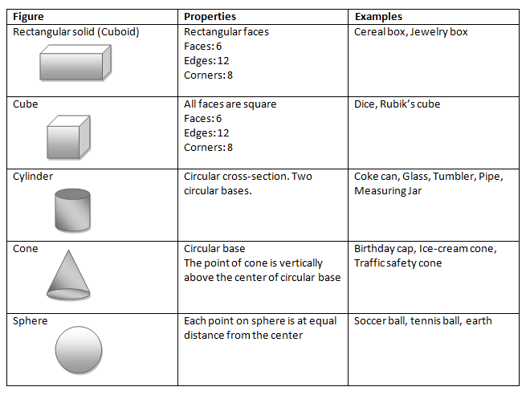

**DO THESE**

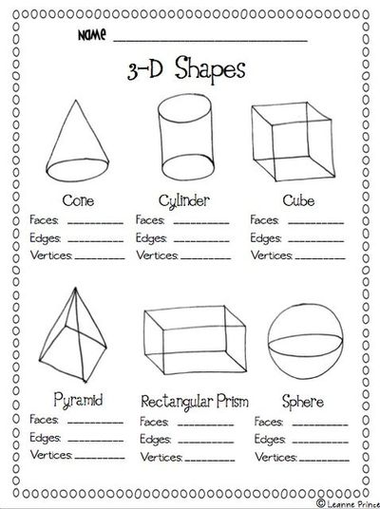

**ASSIGNMENT**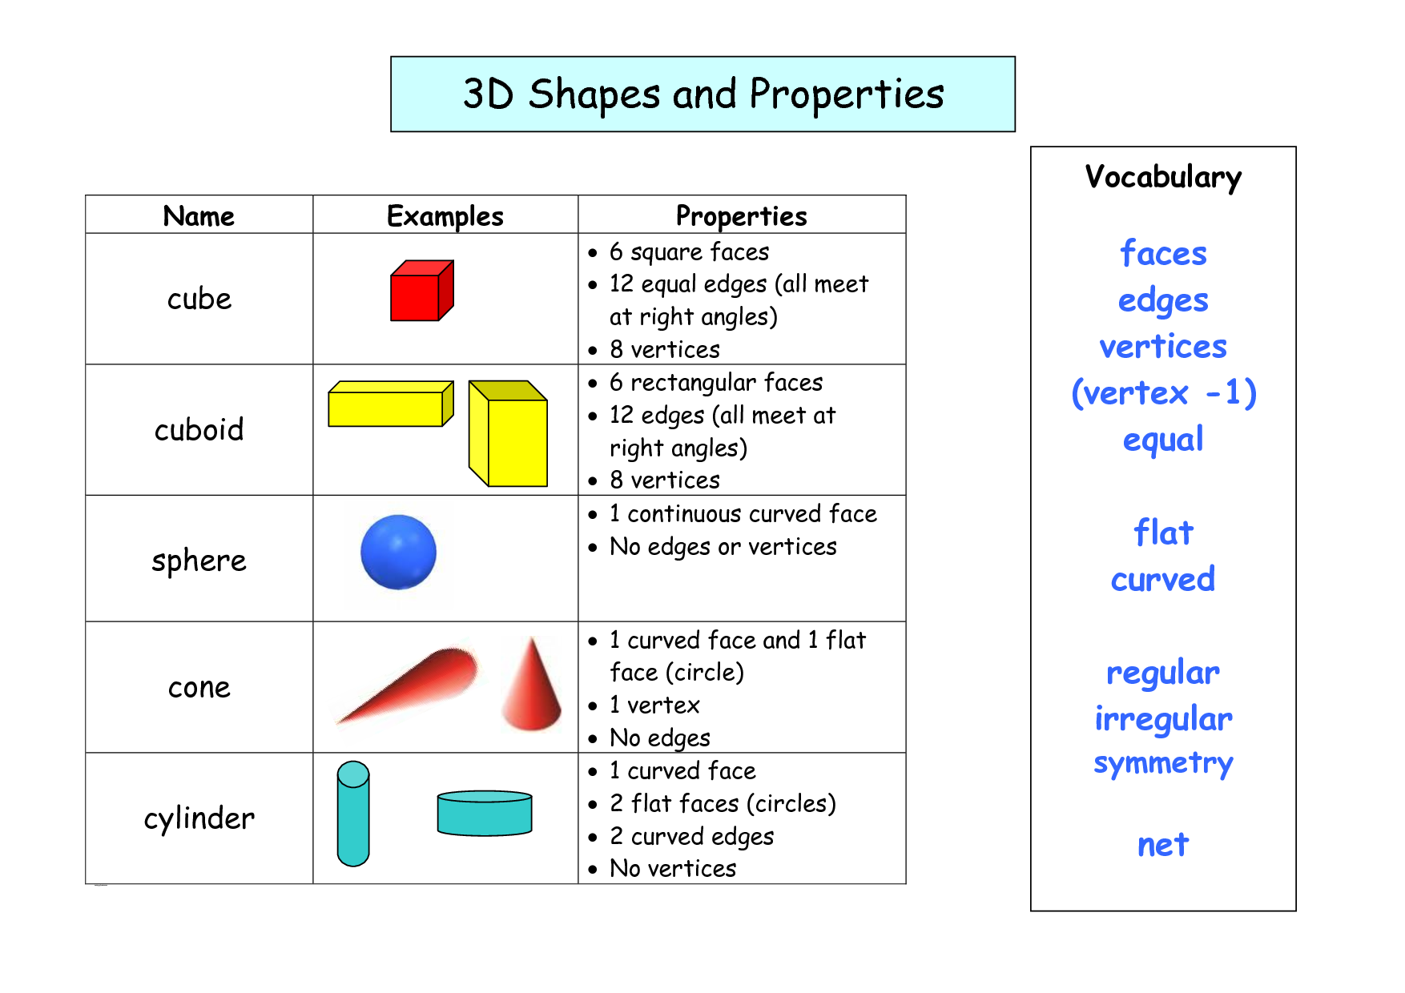

**ASSIGNMENT:**



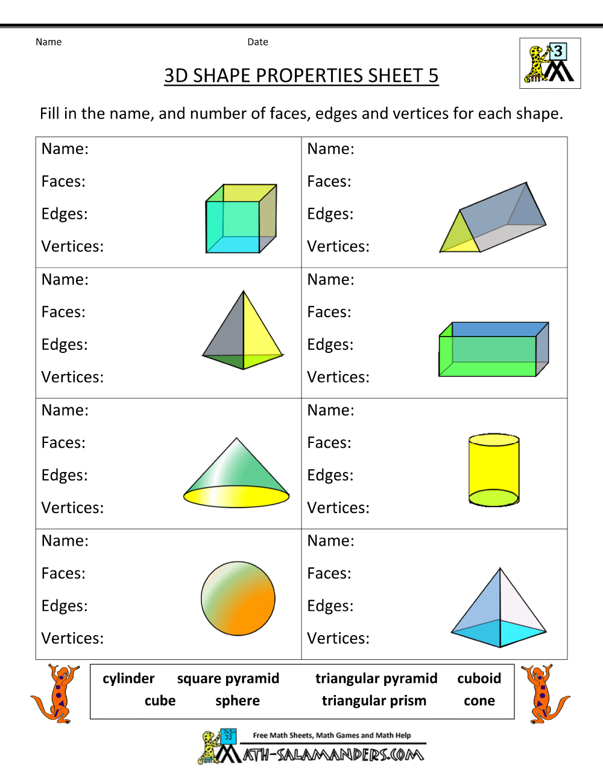

APPLICATION

### Surface Area

The surface area of a figure, is the total area of all the sides of the figure.

Triangular Prism(Right Angle Triangle)

[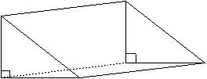](http://wizznotes.com/wp-content/uploads/2010/11/image119.jpg)

To find the surface area of the prism above, follow the steps below.

Step 1:       Divide the figure into smaller shapes.

Step 2:       Find the area of each smaller shape.

Step 3:       Add the areas of each smaller shape.

A right-angle triangle prism can be divided into five smaller shapes; two right angle triangles and three rectangles.

Example

Find the surface area of the prism below.

[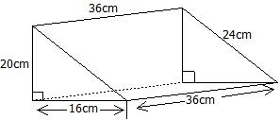](http://wizznotes.com/wp-content/uploads/2010/11/image120.jpg)

[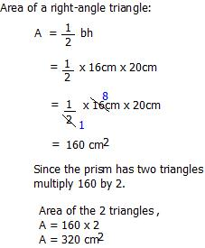](http://wizznotes.com/wp-content/uploads/2010/11/image121.jpg)

[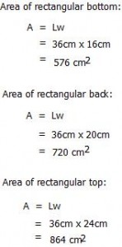](http://wizznotes.com/wp-content/uploads/2010/11/image122.jpg)

[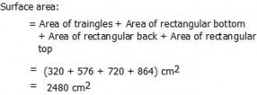](http://wizznotes.com/wp-content/uploads/2010/11/image123.jpg)

Pyramid

A pyramid is an object which has: a straight sided shape base (a squared, rectangular, trianglular base etc) and  triangular sides which meet at the top (called the apex).

[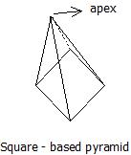](http://wizznotes.com/wp-content/uploads/2010/11/image124.jpg)

[http://wizznotes.com/wp-content/uploads/2010/11/image125-300x54.jpg](http://wizznotes.com/wp-content/uploads/2010/11/image125.jpg)

[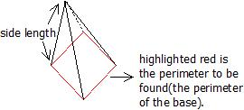](http://wizznotes.com/wp-content/uploads/2010/11/image126.jpg)

Example

[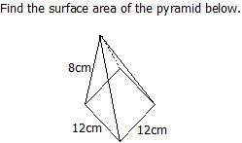](http://wizznotes.com/wp-content/uploads/2010/11/image127.jpg)

[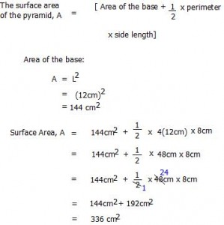](http://wizznotes.com/wp-content/uploads/2010/11/image128.jpg)

Cylinder

[http://wizznotes.com/wp-content/uploads/2010/11/image129.jpg](http://wizznotes.com/wp-content/uploads/2010/11/image129.jpg)

To find the surface area of the cylinder above, follow the steps below.

Step 1:       Divide the figure into smaller shapes.

Step 2:       Find the area of each smaller shape.

Step 3:       Add the areas of each smaller shape.

A cylinder can be divided into three segements: two circles and a curved surface area.

                     The area of a circle, A = πr2

Since there are two circles in a cylinder, multiply the abover formula by 2, that is:

                     The area of the circles, A = 2πr2

 The curved surface area, C.S.A. = 2πrh

The area of a cylinder, A = Area of the circles + C.S.A.

                                                  = 2πr2 + 2πrh

                                                  = 2πr (r + h)

Example

[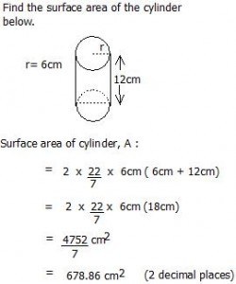](http://wizznotes.com/wp-content/uploads/2010/11/image130.jpg)

Cube

A cube has 6 sides (faces) of the same surface area. Each side (face) of the cube are squares. Recall, the area of a square, A = L2 .

[http://wizznotes.com/wp-content/uploads/2010/11/image131.jpg](http://wizznotes.com/wp-content/uploads/2010/11/image131.jpg)

The surface area of a cube, A = 6L2

Where, L is the length of a side of the cube(all the sides of a cube are the same length).

Example

[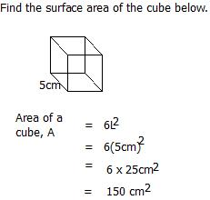](http://wizznotes.com/wp-content/uploads/2010/11/image132.jpg)

Cuboid

[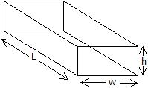](http://wizznotes.com/wp-content/uploads/2010/11/image133.jpg)

The surface area of a cuboid, A =  2Lw + 2 Lh + 2wh

 Where, L is the length of the cuboid

                 w is the width of the cuboid

And,       h is the height of the cuboid.

Example

[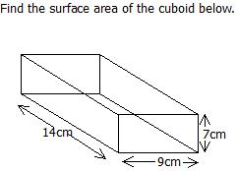](http://wizznotes.com/wp-content/uploads/2010/11/image134.jpg)

[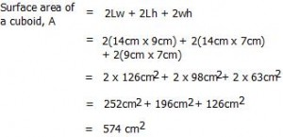](http://wizznotes.com/wp-content/uploads/2010/11/image135.jpg)

Sphere

A sphere is a three-dimensional object (such as a ball or the earth) with every point on the surface equidistant (halfway from) from the center.

The surface area of a sphere, A = 4πr2

Where, r is the radius of the sphere.

[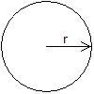](http://wizznotes.com/wp-content/uploads/2010/11/image136.jpg)

Example

[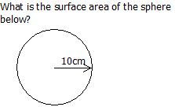](http://wizznotes.com/wp-content/uploads/2010/11/image137.jpg)

Surface Area of a sphere, A = 4 πr2

[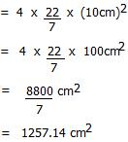](http://wizznotes.com/wp-content/uploads/2010/11/image138.jpg)





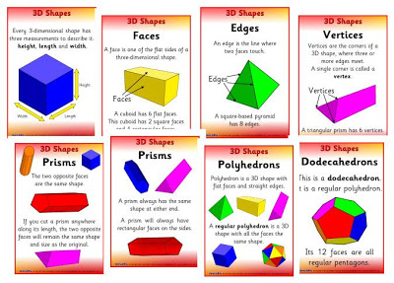

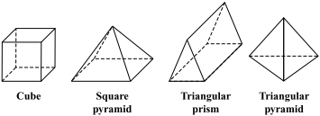



**WEEK 5 AND 6**

**TOPIC: IDENTIFICATION AND PROPERTIES OF ANGLES**

### TYPES AND PROPERTIES OF ANGLES

Straight Angles

Angles which measure exactly 180° (degrees) are straight angles. Therefore, straight angles are straight lines. Angles are represented by the sign ϴ, called theta. That is, for straight angles, ϴ= 180°.

[http://wizznotes.com/wp-content/uploads/2011/01/image0011.jpg](http://wizznotes.com/wp-content/uploads/2011/01/image0011.jpg)

Right Angles

Angles which measure exactly 90° are right angles, that is, ϴ = 90°.

[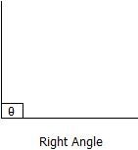](http://wizznotes.com/wp-content/uploads/2011/01/image0022.jpg)

Obtuse Angles

Obtuse angles are those which are greater than 90° but less than 180°, that is, 90° <ϴ< 180°.

[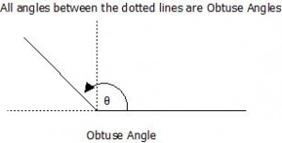](http://wizznotes.com/wp-content/uploads/2011/01/image0031.jpg)

Acute Angles

Acute angles are angles which are greater than 0° but less than 90°, that is, 0° <ϴ< 90°.

[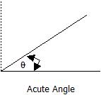](http://wizznotes.com/wp-content/uploads/2011/01/image0042.jpg)

Reflex Angles

Reflex angles are angles which are greater than 180° but less than 360°, that is, 180° <ϴ< 360°.

[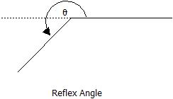](http://wizznotes.com/wp-content/uploads/2011/01/image005.jpg)

Adjacent Angles

Two angles which share the same vertex (centre, usually represented by 0) and have a common side (line) are called adjacent angles.

[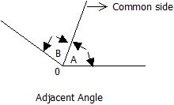](http://wizznotes.com/wp-content/uploads/2011/01/image0062.jpg)

Complementary Angles

Complementary angles are two angles which when summed equals 90°.

[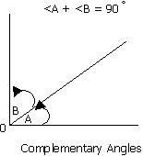](http://wizznotes.com/wp-content/uploads/2011/01/image007.jpg)

Note: <A and <B, are ‘angle A’ and ‘angle B’ respectively.

Supplementary Angles

Supplementary angles are two angles which when summed equals 180°.

[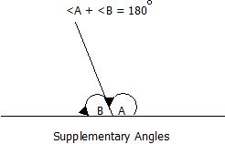](http://wizznotes.com/wp-content/uploads/2011/01/image0082.jpg)

Vertically Opposite Angles

Vertically opposite angles are the angles opposite to each other when two straight lines intersect. Their defining property is that, vertically opposite angles are equal in magnitude.

[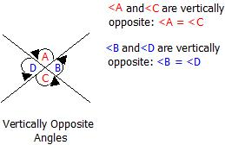](http://wizznotes.com/wp-content/uploads/2011/01/image009.jpg)

Corresponding Angles

When two parallel lines are crossed by a line called the transversal, the angles formed which are in corresponding positions, are called corresponding angles. Corresponding angles are equal in magnitude.

[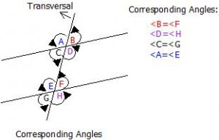](http://wizznotes.com/wp-content/uploads/2011/01/image010.jpg)

Obtuse-Angled Triangles

Obtuse-angled triangles are triangles with one of their angles greater than 90° but less than 180° (i.e. an obtuse angle).

[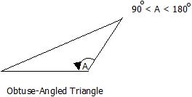](http://wizznotes.com/wp-content/uploads/2011/01/image015.jpg)

Acute-Angled Triangles

Acute-angled triangles are triangles in which all the angles are acute. That is, all angles are greater than 0° but less than 90°.

[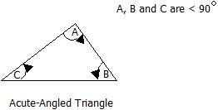](http://wizznotes.com/wp-content/uploads/2011/01/image016.jpg)

**Do these**

Exercise 21.2 pg 240 No ( 1-10)

**Assignment:**  Exercise 21.3 pg 243 No (1 , 2, 5, 6, 10 & 12)

WEEK 7 REVIEWS OF FIRST HALF LESSON

**WEEK 8**

**CONSTRUCTION**

To construct a geometrical figure means to draw it accurately. Generally, to carry out a construction, you required a sharp pencil, compasses, protractor and good ruler. Other mathematical instruments or equipment such as set square, dividers and so on may also be necessary.

The ruler: is used for drawing straight line and also for measuring lengths in both centimeters and inches.

Protractor: A protractor is used for measuring and constructing angles.

Pencil: A pencil with a sharp point is used for drawing straight and curved lines. Drawing pencil may be soft or hard.

A B A B

ANGLE 300  ANGLE 900

A B

ANGLE 600

**Do these**

**WEEK 9**

**TOPIC: STATISTICS**

MEANING AND USES OF STATISTICS

Statistics is the branch of mathematics which deals with the study of data. It involves

* Gathering (collecting data)
* Sorting and tabulating data
* Presenting data usually means of diagrams
* Interpreting results.

**USES OF STATISTICS**

* For record keeping
* To forecast or predict future events
* For planning purposes
* For decision making
* To gather information this can be passes from one source to another.

**TYPES OF DATA**

Qualitative data: this is non- numerical data which can only be described in words. Examples are name, place colour, sex etc.

Quantitative data: A numerical data which is usually given in form of measurement.

**FREQUENCY TABLE**

EXAMPLE 1: The following figures show the number of children per family in a sample of 40 household. 1, 2, 4, 3, 5, 3, 8, 3, 2, 3, 4, 5, 6, 5, 4, 2, 1, 3, 2, 4, 5, 3, 8, 7, 6, 5, 4, 5, 7, 6, 3, 8, 6, 3, 5, 7, 5, 4, 3.

1. Use a tally mark to prepare a frequency table for the data
2. What is the highest frequency of numbers of children per family?

Solution

NUMBER TALLY FREQUENCY

1 // 2

2 //// 5

3 //// //// 9

4 //// / 6

5 //// /// 8

6 //// 4

7 /// 3

8 /// 3

40

3 is the highest frequency of numbers of children

Example 2: In a further mathematics test the following marks were obtained by a group of students 85, 75, 95, 80, 75, 80, 90, 84, 95, 84, 85, 80, 80, 75, 80, 75, 80, 84, 81, 80, 75, 90, 80.

Use tally mark to prepare a frequency table for this data.

Solution:

NUMBER TALLY FREQUENCY

75 //// 5

80 //// 9

81 / 1

84 /// 3

85 // 2

90 /// 3

95 // 2

1. How many students took part in the test? 25 students
2. Which mark had the highest frequency? 80 marks

**WEEK 10**

**STATISTICS: AVERAGE, MEAN, MEDIAN AND MODE**

Average is a single value used to represent a set of numbers (i.e all value in as et data)

The most common ly used statistics is average.

**MEAN = SUM OF THE VALUE/NUMBER OF VALUE**

**MEDIAN = THE NUMBER AT THE MIDDLE AFTER THE ARRANGEMENT OF THE DATA IN INCREASING OR DECREASING ORDER**

**MODE= THE VALUE THAT OCCURS MOST FREQUENTLY.**

**EXAMPLES:** Calculate the mean, media and mode of the following data

1. 45, 50, 55, 54, 48, 53, 50, 55
2. 38, 35, 36, 30.8, 34.7, 37.9, 33.1
3. 3, 0,4,7, 0, 5, 3, 4, 0, 3, 6, 5, 5 ,4, 6, 5

Solution: MEAN= $\frac{∑fx}{n}$ i.e the addition of all the given items, divided by the number of items

Mean = 45+50+ 55+ 54+ 48+ 53+ 50+ 55

8

**= 410/8**

**= 51.25**

**Median = 45, 48, 50, 50, 53, 54, 55, 55**

**50 + 53**

**2**

**= 52**

**Mode = Bimodal which are 50 and 55**

FREQUENCY TABLE: The figure below represents the number of children per family in a sample of 40 house in a street.

1,2,4,3,5,38,3,2,2,3,4,5,6

5,4,2,1,3,2,4,5,3,8,7,6,5,4

5,7,6,3,8,6,3,5,7,5,4,3

1. Prepare a frequency table to represent the information.
2. Draw a bar chart to represent the information

|  |  |
| --- | --- |
| **NO OF CHILDREN PER FAMILY** | **FREQUENCY** |
| 1 | 2 |
| 2 | 5 |
| 3 | 9 |
| 4 | 6 |
| 5 | 8 |
| 6 | 4 |
| 7 | 3 |
| 8 | 3 |

A BAR CHART SHOWING THE NO OF CHILDREN PER FAMILY IN A SAMPLE OF 40 HOUSES

**Frequency**

**10**

**9**

**8**

**7**

**6**

**5**

**4**

**3**

**2**

**1**

**0**

**1 2 3 4 5 6 7 8 no of children per family**

**Do these**

Exercise 24.1 pg 263 No (2, 4, 5,& 6)

Exercise 24.3 pg 266 No (3 & 4)

**Assignment**

Exercise 25.1 pg 270 No (1, 2, 3, 4, & 5)